Name: Hitendra Sisodia

Sap Id: 500091910

**Aim:** Configure a Network topology using two routers on packet tracer software.

**Apparatus (Software):** Packet tracer Software

**Procedure:**

**Step 1:** First, open the Cisco packet tracer desktop and select the devices mentioned below:

|  |  |  |  |
| --- | --- | --- | --- |
| **S.NO** | **Device** | **Model Name** | **Qty.** |
| **1.** | pc | pc | 4 |
| **2.** | switch | PT-Switch | 2 |
| **3.** | router | PT-Router | 2 |

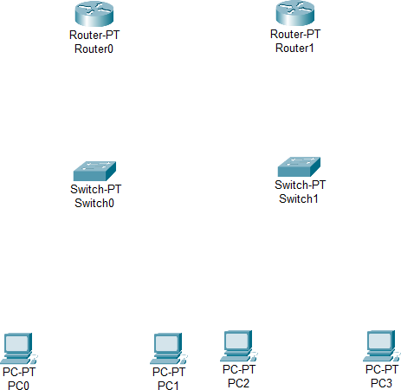

**Step 2:** Then, create a network topology as shown below the image by using an cable to connect the devices with others.

* Connect Router0 to Switch 1 using Copper straight through wire (FA 0/0 =>FA 1/1)
* Similarly Connect Switch to PC0 and PC1 using Copper straight through wire
* Follow the same procedure for connecting Router 1 to Switch 1 and PC2 and PC3.

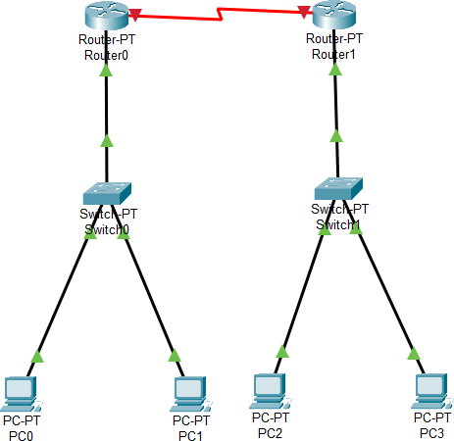

**Step 3:** Configure the PCs (hosts) with IPv4 address and Subnet Mask according to the IP addressing table given above.

* To assign an IP address in PC0, click on PC0.
* Then, go to desktop and then IP configuration and there you will IPv4 configuration.
* Fill IPv4 address, subnet mask and Default gateway.

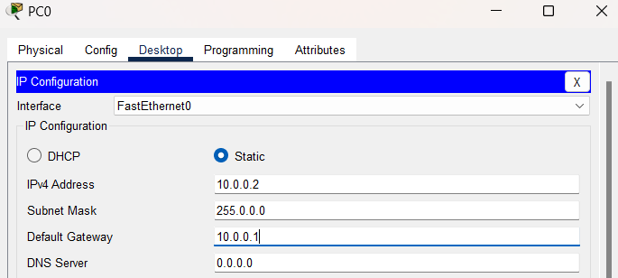

Repeat the same procedure with other PCs to configure them thoroughly.

|  |  |  |  |  |
| --- | --- | --- | --- | --- |
| **S.NO** | **Device** | **IPv4 Address** | **Subnet- Mask** | **Default- Gateway** |
| **1.** | PC0 | 10.0.0.2 | 255.0.0.0 | 10.0.0.1 |
| **2.** | PC1 | 10.0.0.3 | 255.0.0.0 | 10.0.0.1 |
| **3.** | PC2 | 30.0.0.2 | 255.0.0.0 | 30.0.0.1 |
| **4.** | PC3 | 30.0.0.3 | 255.0.0.0 | 30.0.0.1 |

**Step 4:** Configure router with IP address and subnet mask.

* To assign an IP address in router0, click on router0.
* Then, go to config and then Interfaces.
* Make sure to turn on the ports
* Then, configure the IP address in FastEthernet and serial ports according to IP addressing Table.
* Fill IPv4 address and subnet mask.

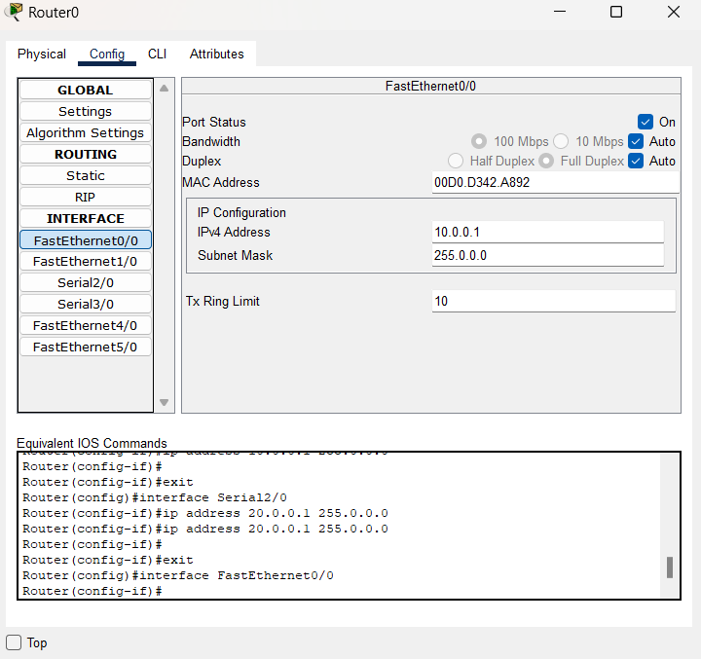

Repeat the same procedure with Router 1 to configure it thoroughly.

# IP Addressing Table Router

|  |  |  |  |  |
| --- | --- | --- | --- | --- |
| **S.N O** | **Device** | **Interface** | **IPv4 Address** | **Subnet Mask** |
| **1.** | router0 | FastEthernet0/0 | 10.0.0.1 | 255.0.0.0 |
| Serial 2/0 | 20.0.0.1 | 255.0.0.0 |
| **2.** | router1 | FastEthernet0/0 | 30.0.0.1 | 255.0.0.0 |
| Serial 2/0 | 20.0.0.2 | 255.0.0.0 |

**Step 4:** After configuring all of the devices we need to assign the routes to the routers.

To assign RIP routes to the particular router:

* First, click on router0 then Go to CLI.
* Then type the commands and IP information given below.

# CLI command: network <network id>

**RIP Routes for Router0 are given below:***Router (config)#network 10.0.0.0*

**RIP Routes for Router1 are given below:***Router (config)#network 10.0.0.0*

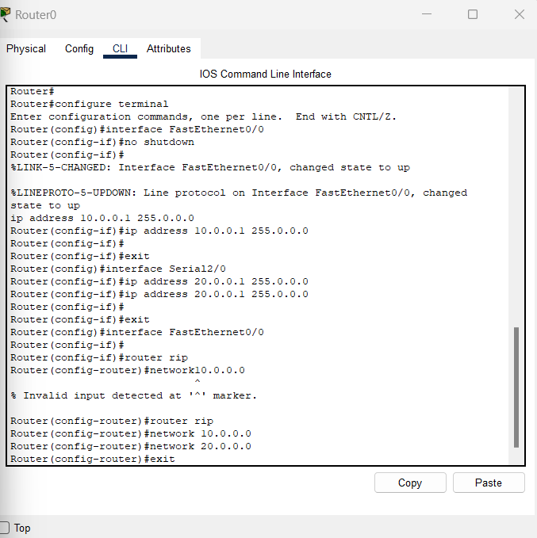

**Step 5:** Verifying the network by pinging the IP address of any PC. We’ll use the ping command to do so.

* First, click on PC0 then Go to the command prompt
* then type ping <IP address of targeted node>
* as We can see in the below image, we are getting replies which means the connection is working very fine.

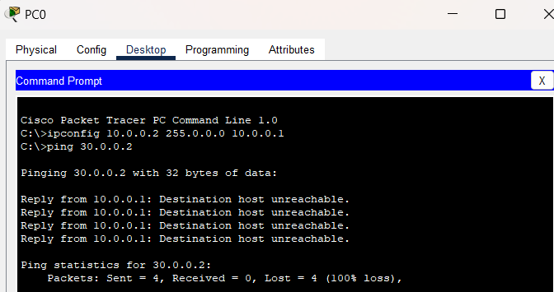

**Step 6:** A simulation of the experiment is given below we are sending PDU from PC0 to PC2 andPC1 to PC3:

